After the brainstorm (read that document if you didn’t) I need to make clear (to me and you) what I will try to implement, and what will be my goal, so let’s start

General Idea
This will be a tower defense game genre located in space, the main concept is that we are a colony of some interplanetary beings (maybe customizable character if I have time) and in the search for new worlds we find that we are being attacked by other interplanetary race (here is when the tutorial starts).

Scenarios
All fights will be in space, if we create some kind of lore about it we can add like planet’s surfaces or atmospheres.

Game concept
As said will be a space game, our ships are going to be our towers, we can conquer enemy’s towers and make ours, or conquer pacifists ships near by (less effort).
- In this game phase all ships are going to start with 30 population, if this population goes to 0 you lose the ship, the population increases in passive way, but if we sent over the ship this ratio decreases.
- If we are attacking our population increase will stop, but if we are fighting we will lose population.
- We can receive population from allies ships
- we win when all enemy’s ship are conquered, lose if ours.
- Score will increase by killing enemy’s soldiers, conquering ships and by time passed (this opens possibility for horde gamemode, but not this version)

Technology
As said before, I will use Unity with C#, I will code my design patters based on https://github.com/Habrador/Unity-Programming-Patterns (I will be more descriptive in documentation) with MVC in top of my head.
For the leaderboard I will create my own API with node.js, express.js and mongodb with design patterns based on: https://www.terlici.com/2014/08/25/best-practices-express-structure.html
For version control I will use git hosted on github.

Functional requirements
Requirement’s number | FR 00
Requirement’s name | Template
Type | Requirement | Restriction
Conditions (if has)
Priority | High | Normal | Low
Requirement’s template

Game menu
Requirement’s number | FR 01
Requirement’s name | Main menu
Type | Requirement
Conditions (if has) | 1st view in game
Priority | High
Description | Is the first view the player is going to see.  It has 2 options:  - Level selector  - Send to FR 02  - Exit game  - Finish the execution of the game

Requirement’s number | FR 02
Requirement’s name | Level menu
Type | Requirement
Conditions (if has) | Child of FR 01
Priority | High
Description | Contains all levels with leaderboard of each.  Each level can be represented as programmer decides with top 5 scores.  Clicking on level should show description of it, your max score and option to play.  One button to return to FR 01

Requirement’s number | FR 03
Requirement’s name | Game pause menu
Type | Requirement
Conditions (if has) | Being playing a mission level or game level
Priority | High
Description | Pauses the game  Show option to quit level (go to FR 02)

Gameplay levels

Requirement’s number | FR 04
Requirement’s name | Tutorial
Type | Requirement
Conditions (if has) | First level playable
Priority | High
Description | In this level we teach the player how to play.  The main objective is that the player understand how to attack.  Convenient show instructions in dialog.  Player should win always.
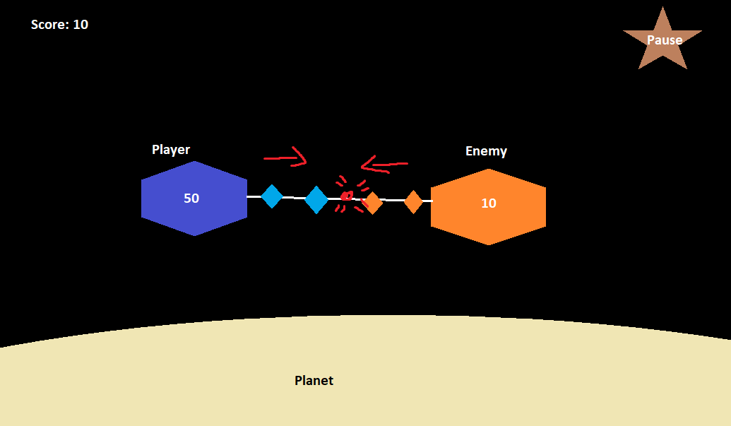

Requirement’s number | FR 05
Requirement’s name | Level 1
Type | Requirement
Conditions (if has) | Tutorial ended
Priority |  | Medium
Description | In this level we teach the player conquer methods

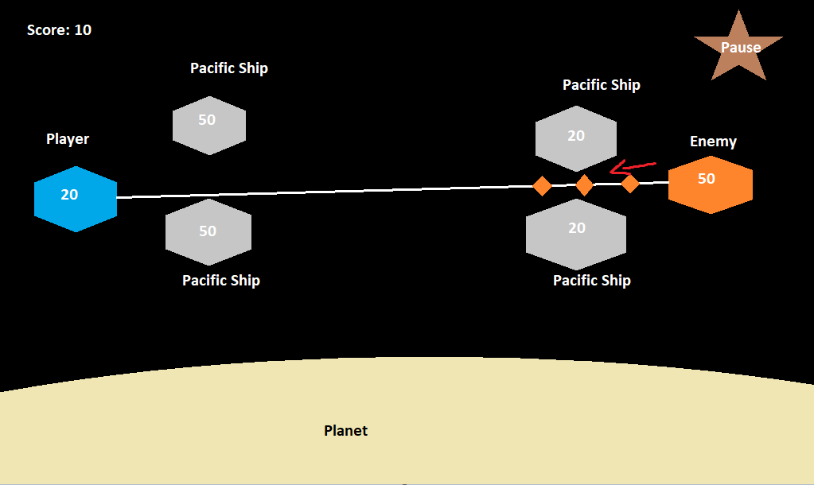

Requirement’s number | FR 06
Requirement’s name | Level n
Type | Requirement
Conditions (if has) | Previous level finished
Priority |  |  | Low/Optional
Description | Design challenging levels

Gameplay mechanics

Requirement’s number | FR 07
Requirement’s name | Attack
Type | Requirement
Conditions (if has) | Ship units needed
Priority | High
Description | Attacking an enemy will create a line that connects attacker and attacked.  If attacking ship directly without response do double damage  If attacking ship’s units both ships will lose units.  If attacking neutral ship, it will require 10 units to conquer.  If attacking team ship, it will transfer units to it.

Requirement’s number | FR 08
Requirement’s name | Conquer
Type | Requirement
Conditions (if has) | If neutral ship 10 units  If enemy/player ship it need to have 0 or less units
Priority | High
Description | If conquering neutral ship, it will start with units marked quantity.  If conquering enemy/player ship, it will start with 5 units

Requirement’s number | FR 09
Requirement’s name | Units
Type | Requirement
Conditions (if has)
Priority | High
Description | Each clock tick will give all players ships (except for neutral ships) units.  Each unit has 100 hp (health power) and 100 ap (attack power)

